If you can’t plant your bare root trees and shrubs right away, or you are receiving planting assistance from SWC, please follow these instructions.

Heeling in Bare Root Trees:
- Select a sheltered spot if possible to heel in your plants. Create a trench by either digging or mounding soil, making one side vertical and the other at a 45 degree angle. Make it wide and long enough to fit all the plants roots and keeping them from crowding. The trench should be about a foot deep.
- Remove any plastic and other wrapping from the roots.
- Lay the uncovered plants down on the sloping side of the trench.
- If you have multiple trees, they can be closely bundled together.
- Spread out the roots along the bottom of the trench.
- Fill the trench with soil, firming lightly.
- Water if the soil is dry. It is important that the roots do not dry out or freeze
- Keep the roots moist, but not soaking wet, until you can plant the tree in its permanent place.

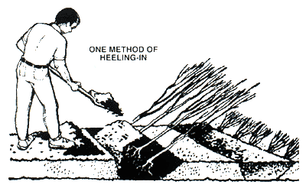

Tips :
If your ground is frozen you can also heel in your bare root trees in a cellar or garage. Use a five gallon bucket and cover the roots with damp sawdust or use a wheelbarrow. There should not be any standing water around the roots.If you see the buds swell, your tree has broken dormancy and needs to be planted right away. When you are ready to put your plant in its permanent place, remove it from the temporary ditch and soak the roots in a bucket of water for up to one hour. Hydrating those roots before planting will ensure success for your tree.

